LivePhoto Physics Activity 19 Name:

Date:

Slinky Wave Speeds
A matter wave is different from a moving particle because it is a temporary disturbance that moves through a medium such as a spring, water, or a metal bar. The disturbance can move between two locations without the matter between the locations.
Transverse and Longitudinal Waves: In this activity you’ll be considering disturbances that move along a Slinky that is stretched and then fixed at each end. There are two types of disturbances that can travel along a stretched Slinky: [1] A few coils at one end can be pulled quickly in a direction that is perpendicular or transverse to the line of stretched coils and released; or [2] A few coils at one end can be bunched together in a longitudinal direction along the line of stretched coils and released. Video frames of each type of disturbance are shown in Figures 1a and 1b and Figures 2a and 2b.

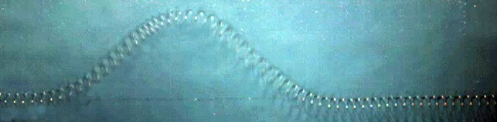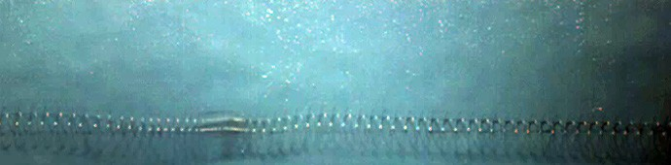
wave crest
leading edge of a longitudinal wave

Figure 1a: A single frame showing a transverse disturbance moving along a stretched Slinky.
Figure 2a: A single frame showing a longitudinal disturbance moving along a stretched Slinky.

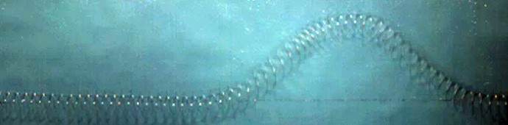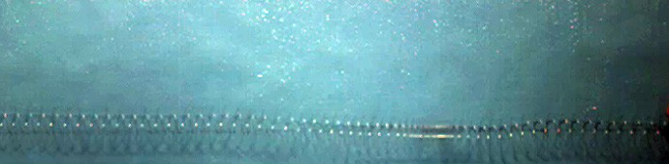

wave crest a while later
leading edge of a longitudinal wave a while later

Figure 1b: A single frame showing that the transverse disturbance has moved about 1/2 meter in 1/8th of a second.
Figure 2b: A single frame showing that the transverse disturbance has moved about ½ meter in 1/8th of a second.

Your task in this assignment is to study movies that show transverse and longitudinal disturbances moving along a stretched Slinky lying on a very slick (low friction) floor. What happens when just a few coils are disturbed in a deliberate manner and released? You’ll be asked to think about the process by which the disturbances propagate along the Slinky, measure the wave speeds, and consider what properties of the Slinky will affect the speed of the waves.
Before starting this activity, you should view the “slow-mo” versions of the transverse and longitudinal QuickTime movies entitled <SlinkyWave_T01(slow-mo).mov> and <SlinkyWave_L10(slow-mo).mov>.

Notes about the Movies: The waves on this Slinky are moving at a rate of over 4 m/s, so we used a high speed video camera to record the motion at 125 frames per second (fps). We have created two sets of movies to enable you to observe and analyze Slinky waves. One set of movies shows the frames being replayed in “slow-mo” at only 15 fps so you can observe the motion. The other set can be used for analysis using the Logger Pro software. They are labeled “hi-speed”.

Preliminary Questions

Note: You will receive full credit for each prediction made in this preliminary section whether or not it matches conclusions you reach in the next section. As part of the learning process it is important to compare your predictions with your results. Do not change your predictions!
- Examine how a coil moves as a transverse wave passes along the spring: Open the Logger Pro file <CoilMotion.cmbl>, which has the movie <SlinkyWave_T01(hi-speed).mov> inserted. In frame 14 of the movie, the y-axis is set to pass through a spring coil that is not yet disturbed. Please examine how this coil moves in the x-and y-directions, if at all, at various times as the wave travels along the spring. Please put an X in each box that describes the motion of the coil during the frames listed in the column.

Frames | Little or no motion in the x-direction | Not moving in the  y-direction | Moving up or down in the  y-direction
13–15 (before) | X | X
21–23 (during) | X |  | X
28–30 (crest) | X | X
34–35 (during) | X |  | X
42–44 (after) | X | X
- Does the coil you are watching ever seem to move any distance in the x-direction? Ignore wobbling. Explain.

The coil doesn’t seem to move any distance in the x-direction since the transverse wave passed through the coil. The reason is simply because the particles are disturbed as the wave passes through the coil. Thus, the matter is not really moved.

- How do you think the speed of the transverse disturbance, vw, would change, if at all, if the spring were stretched further so that it has a greater tension, T, and smaller mass per unit length, µ? Explain the reason(s) for your answer.

vw would: Increase X
Decrease
Stay the Same

v_{w} would increase if the spring were stretched further to acquire a greater tension and a smaller mass per unit length.
This is because v= √(T/μ). This means that the speed is directly related to tension and inversely related to mass per unit length.

- How to you think the speed of the transverse disturbance would change, if at all, if another spring is used that has the same tension but thicker, more massive coils so that its mass per unit length, µ, is increased? Explain the reason(s) for your answer.
vw would: Increase Decrease X Stay the Same

v_{w} would decrease if tension is kept constant but it had a greater mass per unit length.
This is because v= √(T/μ). A constant value in T and an increase in μ means that the inverse relationship between v and μ applies. Greater mass per unit length results to a lower a lower value of v.

Activity-Based Questions

In the activities that follow we would like you to determine the speed of the transverse wave and compare it to the theoretical prediction of the wave speed as a function of the Slinky tension, T, and its mass per unit length (or linear density), µ. Finally you will measure the speed of the longitudinal wave.
- Open the Logger Pro file <WaveSpeed_T.cmbl> and use video analysis to determine the speed of propagation of the transverse wave crest in m/s using the <SlinkyWave_T10(hi-speed).mov>. Explain your procedure and report your results rounded up to 3 significant figures along with the uncertainty (RSME). Note: Don’t forget to scale the movie very carefully using the Set Scale tool (you can repeat the scaling until the green line looks just right). Then move ahead to the first frame that shows the wave crest. You may want to use either the Curve Fit or Model. . . feature in the Analysis menu to determine the velocity.

Measured Transverse wave speed: vw = 4.88 m/s

Uncertainty (RSME) is 0.008545 m

My procedure was to use the add point function in Logger Pro as the crest of the transverse wave moved for about 0.29 seconds. I captured 20 data points in 20 frames and plotted the data. After, I scaled the data to the 1 meter stick in the video. Then, using the curve fit tool, I fitted the data with a linear fit to determine the velocity.
The result was a linear graph that, once fitted, shows that the wave speed was 4.84+/-0.03848m/s.

Uncertainty (RSME) was found to be 0.008548 m.

- Calculate the theoretical speed of a transverse wave: A derivation in most introductory physics texts predicts that the equation for the wave speed of a small amplitude transverse wave on a spring or
string of should be vw = where T is the tension in the spring and is its mass per unit length (or
T μ
linear density). Note: If you predicted in 1(b) and 1(c) that speed should increase with tension and decrease with mass per unit length (i.e., linear density), then the equation for speed is consistent with that prediction.
The T and data for the Slinky, as shown on the title screen of the transverse wave movie entitled
<SlinkyWave_T01(hi-speed).mov>, is given as T = 1.7 N & = 0.081 kg/m
Determine the theoretical value of the wave speed for the transverse wave to three significant figures and show your calculations.

v= √(T/μ)
T=1.7N
µ = 0.081 kg/m
v= √ (1.7N / 0.081 kg/m)
v= 4.58123 m/s
Theoretical Transverse wave speed(V_{w}) = 4.58 m/s

- Measure the longitudinal wave speed: Open the Logger Pro file entitled <WaveSpeed_L.cmbl>
and determine the propagation speed of the longitudinal wave in meters/second shown in
<SlinkyWave_T01(hi-speed).mov>. Explain your procedure. Did you use modeling or curve fitting? Then record your results to three significant figures along with its uncertainty (RSME). Note: Once again don’t forget to use the Set Scale tool to scale the movie very carefully.

My procedure was to use the add point function in Logger Pro at the end of the longitudinal wave as it moved for about 0.29 seconds. I captured 29 data points in 29 frames and then plotted the data. After, I scaled the data to the 1 meter stick in the video. Then, using the curve fit tool, I fitted the data with a linear fit to determine the velocity.
The result was a linear graph that, once fitted, shows that the wave speed was 4.55 +/- 0.02081m/s.

Uncertainty (RSME) was found to be 0.007890 m.

Measured Longitudinal wave speed: vw = 4.57 m/s

Reflections on Your Findings

- Compare results of measured with theoretical values for the transverse wave speed: Calculate the % difference between the theoretical and measured values. If you did not set scale or select wave locations carefully, we expect that there might be up to a 5% discrepancy between the theoretical and measured values of the transverse wave speed for each type of wave. Calculate the % difference between the theoretical and measured values and comment on your results.

Measured value for transverse wave speed was 4.88 m/s and its theoretical value was 4.58 m/s. The percent difference as calculated was 6.6%. This discrepancy could be as a result of not selecting wave locations carefully. Also the measured results were very close to the theoretical value. This enhanced the observation of transverse waves and how they behave in real life. It also provided an insight into how theoretical knowledge to practical applications are related, such as measuring the wave speed of the slinky.

- Compare results of measured values for the transverse and longitudinal wave speeds: How much do your values differ from each other? Notes: (1) If you look at the title screen of the two movies you analyzed in the last section you’ll see that the Slinky tension was very slightly less and mass per unit length very slightly more for the longitudinal wave than for the transverse wave.
(2) The similarity between the two results suggests that the theoretical equations for both types of waves are identical. It is interesting to note that even though most introductory physics texts derive
the expression vw = for transverse waves, we’ve not seen it done for longitudinal waves.
T μ

Measured Transverse Wave Speed: vw = 4.88 m/s Measured Longitudinal Wave Speed: vw = 4.57 m/s
The values differ by 0.31 m/s.

- What did you learn from this Activity about wave propagation on a Slinky or Logger Pro video or equation analysis that you didn’t already know?

Before this particular activity, I didn’t understand the fact that the coil matter is not actually moved, but that the particles were merely disturbed. So, initially when I was tracing the the points on the graph, I was trying to plot them with a moving point before I learned there no movements on the x-axis and the movement of the point was only on y-axis. Hence the activity allowed me to study and visualize that fact.

